Student’s perception of error in video games

Theodore Sobolewski
Stanley Sobolewski
Department of Physics
Indiana University of Pennsylvania

Purpose of the study: Video games are a significant past time for many college students. Most video games simulate physical reality in some way. Game players will enter a world displayed on a screen which represents some real place most likely on this planet. Most every game has some type of motion, be it a falling object, a ballistic, or the motion of a car or a person moving across the terrain. For most young adults, the video game experience occurs years before formal training in physics. My question is – once a student has been exposed to formal physics instruction, will she or he be able to detect inaccurate representation in a video game that purports to show the real world?
We’re developing a simple first person video game involving such common elements such as shooting and ballistic on target or falling bodies. This game will have two different versions; one in which the laws of Newtonian mechanics are obeyed, the other where motion will be depicted with common misconceptions present in the motion. (For example, a common misconception is heavier object fall faster than light objects.) Embedded in the video game will be questions evaluating the subject’s conceptual understanding of physics, as well as questions on the motion observed in the game, along with items regarding past physics experiences.
A quick survey of the literature yields few if any articles that address student’s perceptions of physics misconceptions in video games. While there are quite a few studies that use video games to enhance instruction, then seem to address our issue directly.
Anderson and Barnett investigated the use of video gaming technology to facilitate the understanding of basic electromagnetism with pre-service elementary teachers. The impact of subject’s use of a game called Supercharged was compared with a group who participated in a more traditional inquiry investigation.

Essentially, this is a pilot study for future investigations
They found a significant difference between the control and experimental groups on the gains from pre-to-post assessment. However, while students in the experimental group performed better than their control group peers, they rated their knowledge of the topic lower than the control group. Results of this study show that video games can lead to positive learning outcomes.
Green et. al. investigated the effect of action gaming on the spatial distribution of attention. The authors used the flanker compatibility effect to separately assess center and peripheral attentional resources in gamers versus non-gamers. Gamers exhibited an enhancement in attentional resources compared with non-gamers, not only in the periphery but also in central vision. The authors then used a target localization task to unambiguously establish that gaming enhances the spatial distribution of visual attention over a wide field of view. Gamers were more accurate than non-gamers at all eccentricities tested, and the advantage held even when a concurrent center task was added, ruling out a trade-off between central and peripheral attention. By establishing the causal role of gaming through training studies, the authors demonstrate that action gaming enhances visuospatial attention throughout the visual field

Rodrigues and Carvalho present classroom strategies for teaching kinematics at middle and high school levels, using Rovio's famous game Angry Birds and the video analyzer software Tracker. We show how to take advantage of this entertaining video game, by recording appropriate motions of birds that students can explore by manipulating data, characterizing the red bird's motion and fitting results to physical models. A dynamic approach is also addressed to link gravitational force to projectile trajectories.

Shute et al. are examining ways to leverage video gaming environments to assess and support student competencies. The authors examine gameplay and learning using a physics game they developed called Newton's Playground. The sample consisted of 167 eighth- and ninth-grade students who played Newton's Playground for about 4 hour over the course of 1.5 weeks. Findings include significant pretest–posttest physics gains, and significant relations between in-game indicators and learning.
Process
Subjects initially took a 10 question assessment. Questions were selected from the FCI, one question for each of Newton’s laws. This was done to minimize the time on the task. (We call this the “Mini-FCI”
Next they were presented with four video clips. The subjects had to state if there was an error or not. If they thought there was an error, they were asked to state the error.

Example – Falling
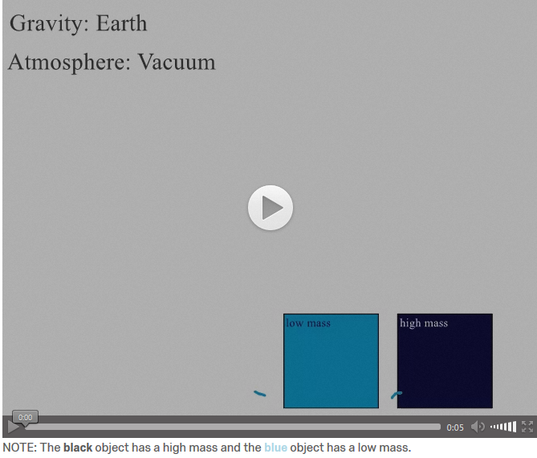
It is stated that the two blocks below have different masses. As they fall mass identified as heavier hits the ground first. This item had errors, yet half of the respondents stated no error was present.

Subject’s response | Mini FCI Score
The two objects should be landing at the same time, shouldn't they? | 3
None | 3
none | 3
none | 2
none | 5
The high mass reaches the ground faster then the low mass because gravity was pulling it down | 3
Should hit at same time | 6
They would fall at the same rate | 4

Example - Collision
A truck crashes into a brick wall. Essentially, there are no errors in the clip.

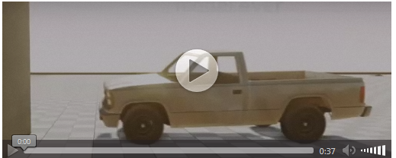

Subject’s response | Mini FCI Score
The car looks like it's made of rubber. It bounces off the wall too much. A little bounce is reasonable, but this is too much. Also, the wall should be taking some damage. | 3
None | 3
None | 3
the mirror kind of freaks out the whole time and decides which direction it wants to fly. | 2
none | 5
The speed of the car forced how much more damage the car would take | 3
nothing noticably wrong None | 6
The car would exert some force on the walls and the car front would not completely deteriorate like that | 4

Discussion – the sample size was too small to conduct statistical analysis. Anecdotally, it seems that there is a connection between physics conceptual understanding and identifying errors in video. Subjects with higher Mini-FCI scores more often correctly found errors in the videos.
Anderson, Janice; Barnett Michael Using Video Games to Support Pre-Service Elementary Teachers Learning of Basic Physics Principles, Journal of Science Education and Technology August 2011, Volume 20, Issue 4, pp 347–362
Green, C. Shawn; Bavelier, Daphne, Effect of action video games on the spatial distribution of visuospatial attention.
Journal of Experimental Psychology: Human Perception and Performance, Vol 32(6), Dec 2006, 1465-1478.
Merrilea J. Mayo, Video games: A route to large-scale STEM education? Science Jan 2009, Vol. 323, Issue 5910, pp. 79-82 DOI: 10.1126/science.1166900
M Rodrigues; P Simeão Carvalho Teaching physics with Angry Birds: exploring the kinematics and dynamics of the game Physics Education 2013 IOP Publishing Ltd, Volume 48, Number 4
Shute Valerie J., Ventura, Matthew, and Kim, Yoon Jeon, Assessment and Learning of Qualitative Physics in Newton's Playground, The Journal of Educational Research Vol. 106, Iss. 6,2013

